**Machine Learning Activity 11**

**Group Members**

22339019 Mbhele S

22202388 HA Gwala

Technical programming 2

**Directed Graph**

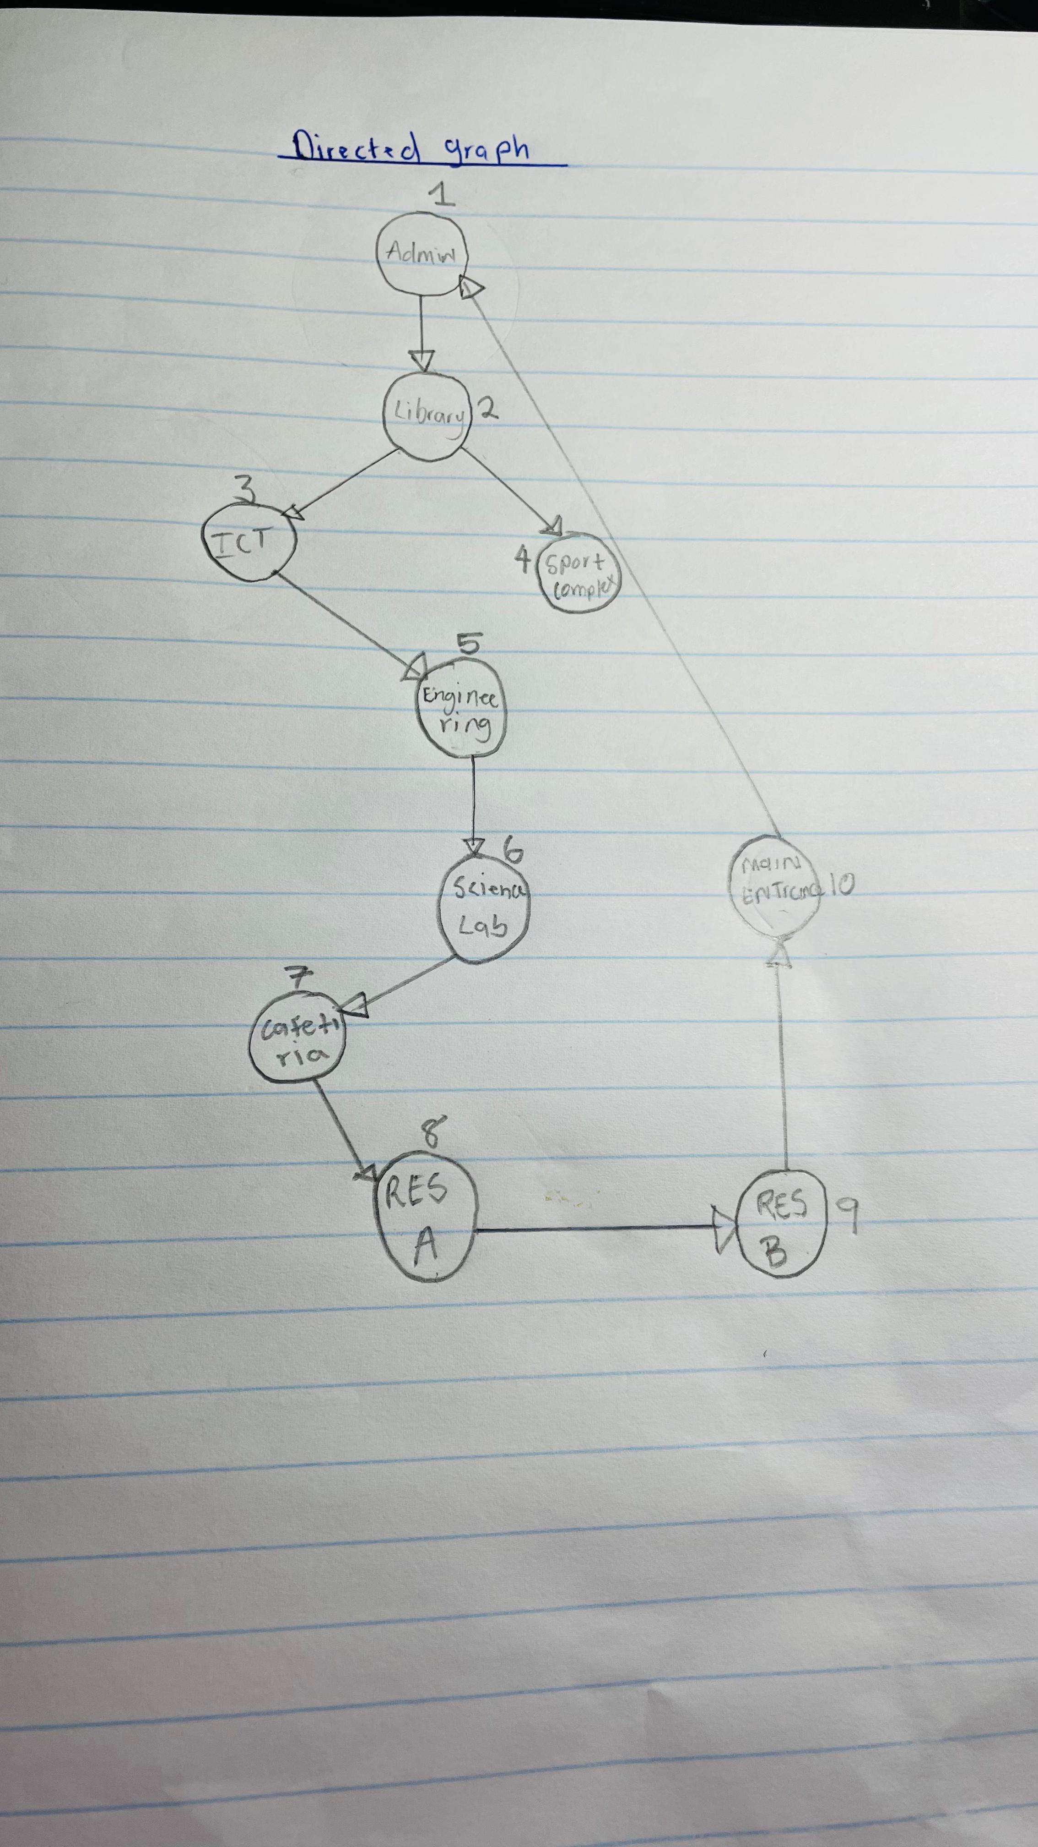

**Adjacency Matrix and Adjacency List**

